CONSUMER BEHAVIOR IN ONLINE GAMES

Mariia Igorevna Okuneva

the 4th year of bachelor degree, Faculty of Economics

HSE-Perm, Perm
E-mail:miokuneva2@gmail.com

Supervisor: Dmitriy Borisovich Potapov

HSE-Perm Deputy Director, Associate Professor
E-mail: dbpotapov@gmail.com

ABSTRACT
The present paper focuses on the concepts of motivations and fun in online games. The ultimate goal of our research is to understand consumer behaviour toward an online games extending Yee’s model of motivations (Yee, 2006). We investigate relationships between fun, motivations, continued intention to play and such characteristics of players as age and rank. Our calculations are based on statistical procedures (structural equation modeling) for players of one particular game “Tanki Online”.
Key words: MMOG, motivation, fun, flow state, SEM

АННОТАЦИЯ
В статье изучаются понятия мотивации и удовольствия в онлайн-играх. Исследование потребительского поведения основано на модели мотиваций Ника Йи (Yee, 2006). Рассматриваются связи между удовольствием, мотивациями, лояльностью и такими характеристиками игроков, как возраст и звание. Для расчетов используется метод моделирования структурными уравнениями.
Ключевые слова: онлайн-игры, мотивации, моделирование структурными уравнениями

Research Model and Hypothesis
The conceptual model for the present study is shown in Figure 1. At the bottom three motivations for play in online games are presented: (i) achievement; (ii) social interactions; (iii) immersion. These are linked to flow state that acts as proxy for fun and continued intention to play games. According to many studies (Choi, 2004; Lee, 2010), flow state is linked to continued intention to play (it is also called behaviour loyalty, future play, usage etc.).
Motivations
The motivations that constitute a part of our model are adopted from Yee’s paper (Yee, 2012). He used factor analysis twice to reveal ten motivations at the first stage and three kinds of overarching, non-exclusive motivations for play at the second one – achievement, social component, immersion.
Flow state and motivations
We suggest that people play games because they are intrinsically satisfying and provide players with fun (Koster, 2005; Bartle, 2003). R. Ryan in his paper (Ryan, 2006) investigated the relationship between enjoyment and three kinds of motivations – competence, autonomy and relatedness. At the same time, he asserts that Yee’s social, achievement and immersion motivations do not statistically influence enjoyment. However, it seems that model of Ryan suffers from multiocollinearity problem because such constructs as Yee’s social motivation and relatedness were strongly correlated as well as competence and autonomy. Moreover, the relationship between social interaction and flow state was empirically tested in many works (Choi, 2004); escape motivation (the component of immersion) has an impact on engagement (that is close to flow state), according to D. Koo (Koo et al., 2007). We do not know studies about relationship between achievement and fun since achievement was not regarded as motivation in prior empirical research. Nevertheless, we assume that they are strongly positively related, because if something is of high value for a player and no one makes him play games the user should derive enjoyment from the game.
Hypothesis H1: Achievement has a positive effect on flow state.
Hypothesis H2: Social motivation has a positive effect on flow state.
Hypothesis H3: Immersion has a positive effect on flow state.
Continued intention and motivation
Yung-Shen Yen in his paper (Yen, 2011) claims that perceived value from information, social and hedonic aspects positively influence continued usage intention. While this research was carried out with respect to social networking sites, we suppose that indicated relationship is relevant to online games too. Perceived value in our mind is tightly correlated with motivations that also refer to crucial for users things. Therefore, this study brings forth three next hypothesis:
Hypothesis H4: Achievement has a positive effect on continued intention.
Hypothesis H5: Social motivation has a positive effect on continued intention.
Hypothesis H6: Immersion has a positive effect on continued intention.
Flow state and continued intention
The more a player is satisfied with the game, the greater his desire to continue playing. The relationship between customer usage and attitudinal measure is discussed in several prior studies (Davis, 1989; Hsu and Lu, 2004). Y. Yen (Yen, 2011) also approves that final user satisfaction positively influence continued user intention. Therefore, in this research, positive relationship between flow state and continued intention may be found.
Hypothesis H7: Flow state has a positive effect on continued intention.
Age and rank of the player
We do not have theoretical background about an impact of age or rank of the player neither on flow state nor on continued intention to play.
Many online games have signs of player’s success. The more the user kills, or completes other tasks, the higher his rank in the game. Relationship between rank and flow or rank and continued intention depends on ability of game designers to capture their consumers. If a new level and a new rank are unique and even more fascinating than the previous ones, the player will have a desire to continue playing and will derive enjoyment from a game.
We do not know whether age influences flow state and continued intention to play but would like to control this possible effect. Therefore, this study brings forth seven next hypothesis:
Hypothesis H8: Rank of the player has a positive effect on continued intention.
Hypothesis H9: Rank of the player has a positive effect on flow state.
Hypothesis H10: Age has an impact on continued intention.
Hypothesis H11: Age has an impact on continued flow state.

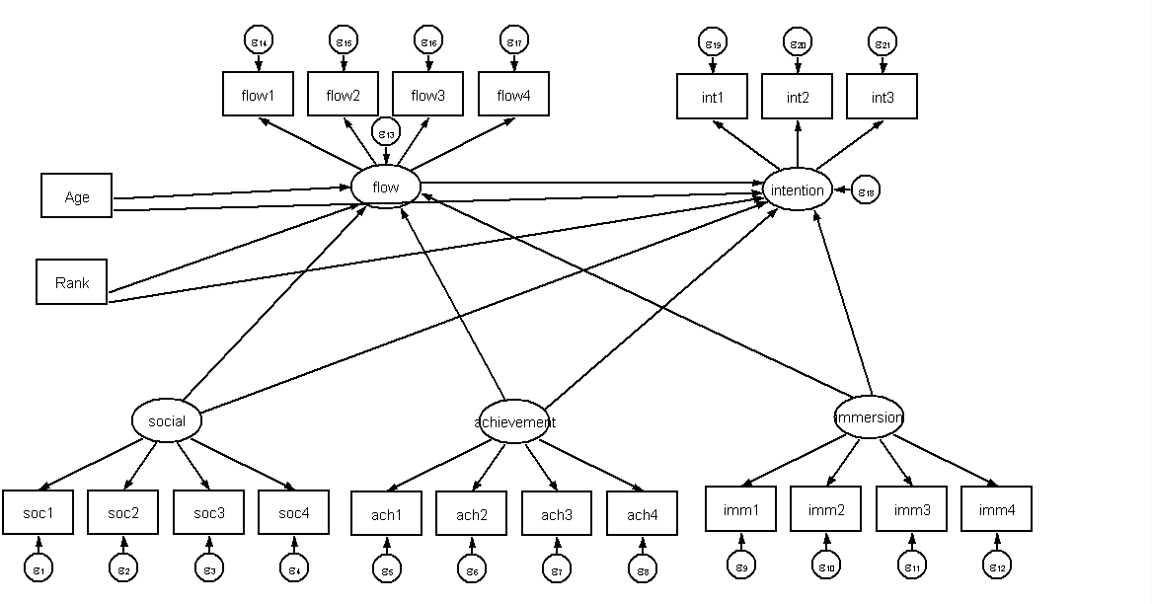
Figure 1. Hypothesized research model

Methodology
We developed a structured questionnaire to be answered by online game users for an empirical investigation of the influential factors on proxy for fun (flow state) and to verify the whole model. Questionnaire items were adopted from previous works (Yee, 2012; Lee, 2010) and modified for the context of particular game “Tanki Online”. Each item associated with motivations in the questionnaire was measured using a 7-point Likert scale with 1 (not at all important) and 7 (extremely important), while items for flow state construct were measured in the same way with the only difference that 1 was equal to ‘strongly disagree’ and 7 – ‘strongly agree’. Players were asked about age, frequency of playing games (days a week and hours a day) and their rank in the game. The present study acts as a pilot test to verify that the questionnaire items are appropriate for the survey in terms of its structure and language and that revealed relationships are consistent with theoretical background. Preliminary validity of the questions was examined by online game experts who found that items are highly associated with corresponding constructs. From our final questionnaire involving 289 respondents, we tested and analyzed our research model and hypotheses. Demographic profiles gathered from survey include information about age, experience, gender and rank of the respondents, the number of hours a day and days a week they play, how much users paid in last 30 days. Everyone who filled in the questionnaire on the game’s forum got a reward of 2000 crystals (in-game currency).

Results
We used the value of Cronbach's alpha to identify the internal consistency reliability of our questionnaire items. Cronbach's alpha for each construct was observed to be greater than .60 (Table 1).
Table 1
Reliability checks for constructs
Constructs | Items | Cronbach's α
Achievement | 4 | 0.633
Social | 4 | 0.658
Immersion | 4 | 0.628
Flow state | 4 | 0.822
Continued intention | 3 | 0.779

To assess the research model, we performed structural equation modeling for variables with Stata 12. All observed variables contribute to the identification of the latent variable at p<0.001. It means that the questionnaire items are appropriate for the survey in terms of its structure and language. As shown in Table 2, chi-square testing as indicated by chi-square fitness is rejected. This preliminary goodness of fit statistics suggests that the measurement model is worse than saturated model, but we do not want to add relationships that are not supported by theory and to improve the model artificially. Moreover, as the chi-square statistics is not always the best indicator of model fit, a range of additional fit indices is reported in Table 2. While RMSEA (root mean squared error of approximation) is a bit higher than 0.1, coefficient of determination is relatively high (0.995) and standardized root mean squared residual (0.179) is low enough. Thus, it is concluded that goodness of fit indices is wholly satisfactory to suggest that the measurement model fits the collected data.
Table 2
Fit Indices of the Research Model
CMIN/p | CMIN/df | RMSEA | SRMR | CD
0.000 | 4.84 | 0.115 | 0.179 | 0.994
CMIN/p = chi-square fitness; CMIN/df = chi-square/degree of freedom; RMSEA = root mean square error of approximation; SRMR= standardized root mean squared residual; CD= coefficient of determination

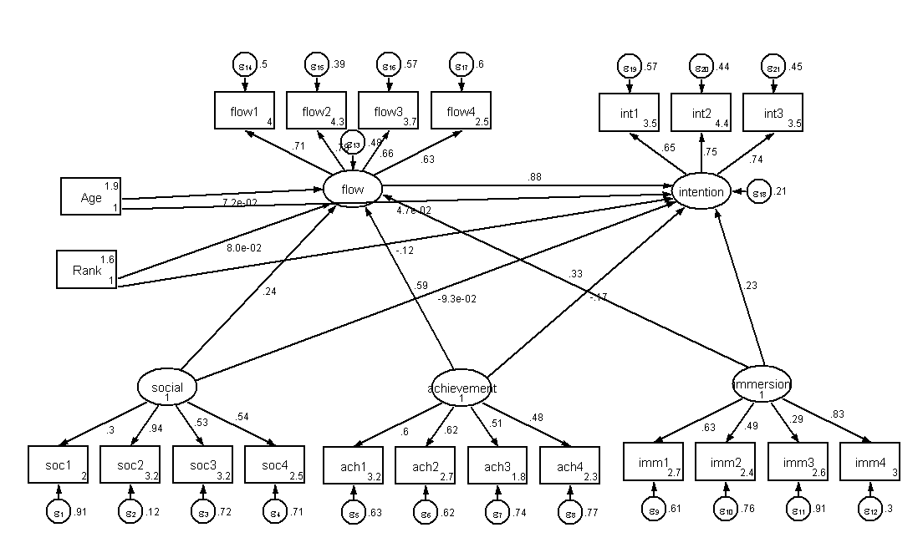
Figure 2. Results of structural modeling analysis.
As shown in Table 3 six of the eleven hypothesized paths were significant. The results showed that achievement, immersion and social motivations positively affect flow state that is consistent with theory. The most important motivation for players is achievement (β=0. 572) that in our opinion is associated with the type of the game, it is followed by social motivation (β=0.372), the third one is immersion (β=0.280). At the same time, only immersion directly influences continued intention to play games, achievement and social motivations have an impact on continued intention through intermediary – flow state. For game designers it means that in order to make users continue playing online games, they should create new content that players will explore, pay attention to guides, video blog, appearance of characters. The relationship between flow and continued intention is relatively strong and positive (β=0. 919). It approves the fact that the happier a player the higher his intention to continue playing. The relationship between rank of the player and his intention to continue playing is significant but has an opposite direction with respect to our prediction: the higher the rank of the player the less his desire to continue playing. This discovery may be associated with lack of new content and immersion correspondingly at higher levels of the game and motivates us to carry out another research about the level where players often become bored.
Table 3
Summary of the Estimated Path Coefficients
Path | Estimate | p-value | Hypothesis testing
Achievement→flow | 0.572*** | 0.000 | Supported
Social→flow | 0.372*** | 0.009 | Supported
Immersion→flow | 0.280*** | 0.000 | Supported
Achievement→CI | -0.168 | 0.178 | Not supported
Social→CI | -0.153 | 0.210 | Not supported
Immersion→CI | 0.204** | 0.007 | Supported
flow→CI | 0.919*** | 0.000 | Supported
Rank→CI | -0.012** | 0.042 | Supported (opposite direction)
Rank →flow | 0.007 | 0.209 | Not supported
Age→CI | 0.004 | 0.383 | Not supported
Age→flow | 0.005 | 0.219 | Not supported
flow = flow state; CI = continued intention to play the game; ***p<0.01; **p<0.05; *p<0.1.

All in all, we found out that fun in online games is really associated with three components – achievement, socializing and immersion.

REFERENCES
Bartle R. (2003) Designing Virtual Worlds. // New Riders.
Choi D., Kim J. (2004) Why people continue to play online games: in search of critical design factors to increase customer loyalty to online contents. // Cyberpsychology & Behavior: The Impact Of The Internet, Multimedia And Virtual Reality On Behavior And Society. // Volume 7. Issue 1. – p. 11-24.
Davis F.D. (1989) Perceived Usefulness, Perceived Ease of Use, and User Acceptance of Information Technology. // MIS Quarterly. Vol. 13. Issue 3. – p. 319-340.
Hsu Chin-Lung, Lu His-Peng (2004) Why Do People Play On-line Games? An Extended TAM with Social Influences and Flow Experience. // Information & Management. Vol. 41. – p. 835-868.
Koo Dong-Mo, Lee Soo-Hyung, Chang Heung-Seub (2007) Experiential Motives for Playing Online Games. // Journal of Convergence Information Technology. Volume 2 Number 2. – p. 37-48.
Koster R. (2005) A Theory of Fun for Game Design. // Paraglyph Press.
Lee Ming-Chi. (2010) What Drives People to Continue to Play Onine Games? An Extension of Technology Model and Theory of Planned Behaviour. // International Journal Of Human-Computer Interaction. Volume 26. Issue 6. – p. 601-620.
Ryan R. M., Rigby C. S., and Przybylski A. (2006) The motivational pull of video games: A self-determination theory approach. // Motivation and Emotion. Vol. 30. No. 4. – p. 344–360.
Yee N. (2006). Motivations for Play in Online Games. // CyberPsychology and Behavior. Vol. 9. – p. 772-775.
Yen Yung-Shen. (2011) The Impact of Perceived Value on Continued usage Intention in Social Networking Sites. // 2nd International Conference on Networking and Information Technology IPCSIT. Vol.17. IACSIT Press, Singapore. – p. 217-223.

